PAC GOLDEN JUBILEE
50 YEARS OF THE PINNER CHURCHES
WORKING TOGETHER

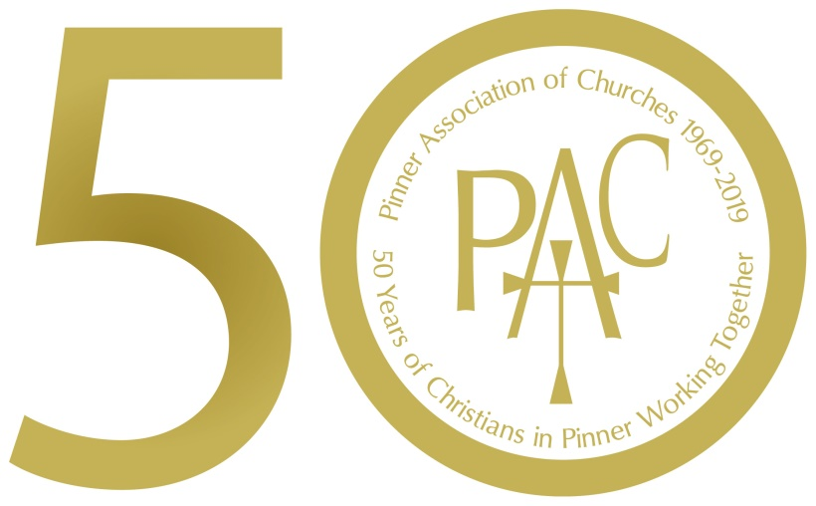

You are invited to join us for our
Golden Jubilee Celebration Weekend

Golden Jubilee Service
Sunday 9 June 3.00pm
St. Luke’s Roman Catholic Church, Love Lane
With reflections on the work of the PAC
over the last 50 years

Followed by a celebration buffet reception
in the church hall with a 50th anniversary cake

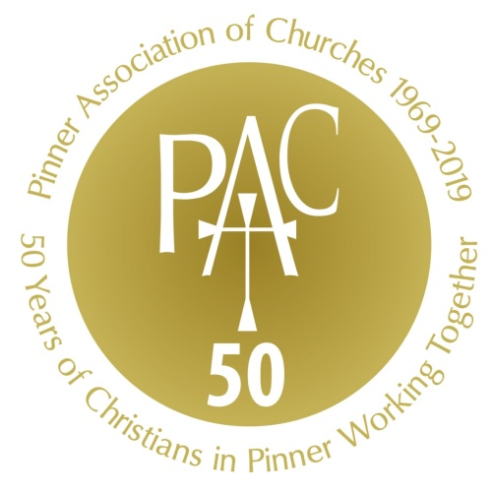

EXHIBITION IN THE VERDEN GALLERY
West House, Pinner Memorial Park

Friday 7 June 1.30pm – 4.30pm
Saturday 8 June 10.00am – 4.00pm

History, photos and memorabilia
And what the Churches do today!

Saturday 8 June 10.00am – 4.00pm
Family Fun for all ages
Scavenger Hunt in the park
crafts and other activities
Come to The Verden Gallery to get started

Admission free to Exhibition and activities
Any queries to PAC Chairman: Colin Nunn Tel. 8428 9439
www.pinnerchurches.org.uk

