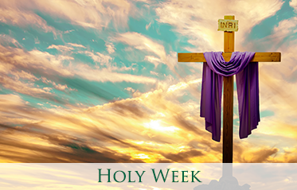
JURY SERVICE IN HOLY WEEK

Have you ever wished that you could do jury service?
If you have never had that opportunity or if you have reached the age beyond which you are obliged to do so, you will have such an opportunity during Holy Week 2019. There will be a few differences between jury service as you know it and Holy Week jury service. During this week we will be invited, using a book by Susan Brown, to listen each evening to an eyewitness account of some of the events as they unfolded during that week. These accounts are based on scripture and are given in an imaginative way. As jurors, you will be encouraged to reflect prayerfully on the accounts given by the various witnesses. And you are also encouraged to discuss this evidence beyond the four walls of the church.
Each evening, a witness will be questioned by a lawyer and each evening will end with a prayerful reflection. On Good Friday, we will hear accounts from various witnesses.
The programme is as follows:
Monday 15 April 2019: 7.30 pm Eastcote: Evidence by a stall holder in the temple
Tuesday 16 April 2019: 7.30 pm Cannon Lane: Evidence from the woman who anointed Jesus’ feet
Wednesday 17 April 2019: 7.30: Pinner A Pharisee will testify
Thursday 18 April 2019: 8 pm Cannon Lane: Peter will testify. This will be followed by Holy Communion and our Tenebrae (shadows) service. Note the later starting time; it needs to be dark outside for the Tenebrae service
Friday 19 April 2019: 9.45 am: Pinner Short service, 15 minutes, before Walk of Witness at 10.20am. 12.15 pm at Eastcote: Our Good Friday service will focus on more evidence from Peter, as well as from Mary, mother of Jesus, Pilate and one of the army officers involved in the crucifixion.
Sunday 21 April: 9.30 am: Pinner: Resurrection service with Holy Communion
Sunday 21 April: 11 am Eastcote: Resurrection service with Holy Communion
I encourage you to come and experience Easter. It is important that it be an experience in which we use all our senses and imagination. For the true meaning of Easter does not lie in factual accounts, but rather in trying to imagine ourselves in the midst of the events as they unfold.
The traditional hymn asks the question:
“Were you there when they crucified my Lord?” We were not there, but we will have an opportunity to be there, even though it is only in our imagination.

